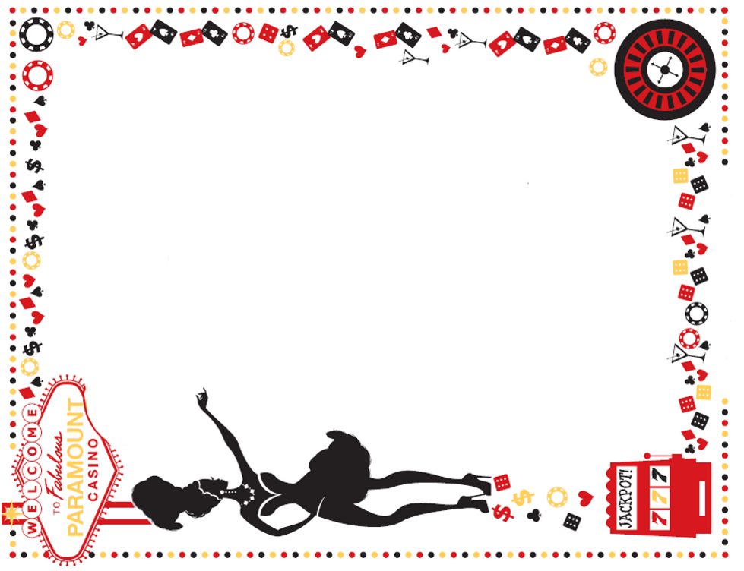
A Weekend of Black Ties and Bling
aka – what happens in Vegas Stays in Vegas
JULY 26th and JULY 27th
Casino (Poolside) Attire requested:
Gentlemen: Black Ties (only) – we will have extras if you don’t own one
Ladies: Your finest (gawdiest) Blinging Necklaces
FRIDAY AFTERNOON (7/26):
1:00 – 4:00 pm Floating Craps Games in the Pool*
1:00 – 4:00 pm Soft opening of our Casino/Games*
4:00 – 6:00 pm Free Early-Bird Buffet for our Casino guests (aka potluck)
Evening music Poolside/Casino
*gaming tokens provided – no charge
ALL DAY SATURDAY (7/27):
9:00-10:00am Water Aerobics at our Classy Casino Spa (aka the pool)
10:00-11:00am Water Volley Ball
Complimentary Continental Breakfast for our Spa Guests
Noon – 4:00 pm – Casino Grand Opening!!
Casino Games: Yard Craps, Roulette, Poker, Bingo, Black Jack, Russian Roulette, Slots…
$$$ Free Casino Cash provided to all our guests and members for your gaming pleasure $$$
$$$ See the Casino Pit Boss for your cash $$$
Vegas Chapel: Opens at Noon
4:00 – 4:30pm – Turn in all Casino Cash for Raffle Tickets
4:30 – 5:30pm – Raffle Drawings
5:00 – 6:30pm – Dinner in the Club House (see flyer for menu)
6:30 – 8:30pm – Las Vegas Murder Mystery (following dinner)
8:30 -? – Poolside Re-cap and Unwind

